**Historical Field Trip**

**The Dept. of History of Govt Degree College Gummalakshmipuram organized a one day historical tour to Bobbili Fort; Guest House was Pillar at Bobbili on 22.03.2025 along with 57 students, 2 Lecturers and one office subordinate.**

**The APSRTC book was booked by the Principal Dr. T. Sreevaram from Gummalakshmipuram to Bobbili. The bus started at Gummalakshmipuram by 8:15 am and it reached Bobbili Guest House at 11:30am.**

**Guest House was built 150 years ago and one of the best architectures in the Indian History.**

**Museum was also visited by our students. In the museum old weapons were used in the war time where they were kept. Nearly 100 to 120 people visit this museum every day. The war pillar was also visited, Kum A. Srivani, Lect in History explained the significance of the pillar and the fort.**

**Bobbili fort located in the Vizianagaram district of the Indian state of Andhra Pradesh was built during the middle of the 19th century in bobbili.**

**Bobbili war was in 1957 between the Rajas of bobbili and the neighboring maharaja of Vizianagaram.**

**Our students visited the above also and they felt very happy. And also they noted all the historical events in these notebooks.**

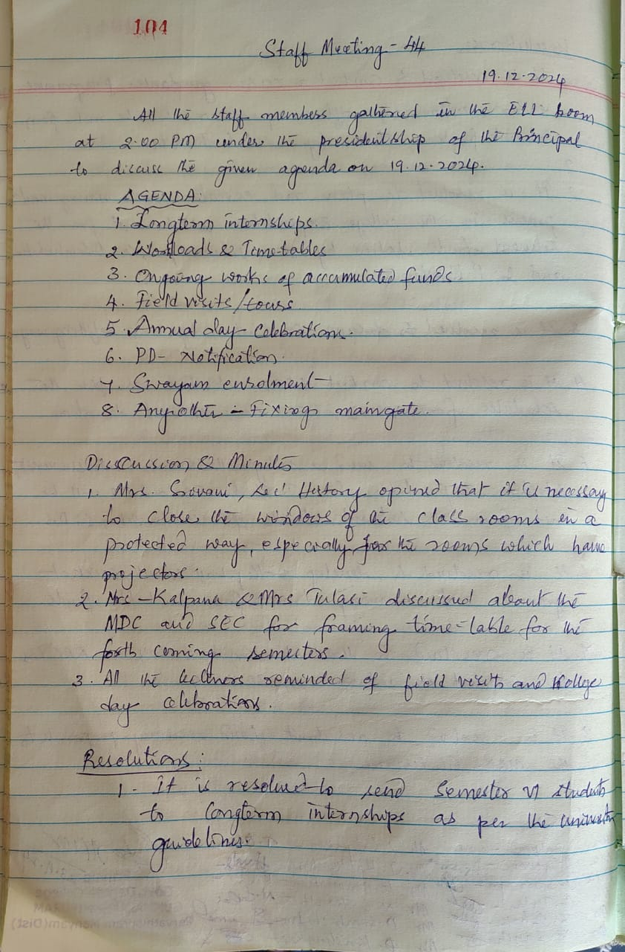

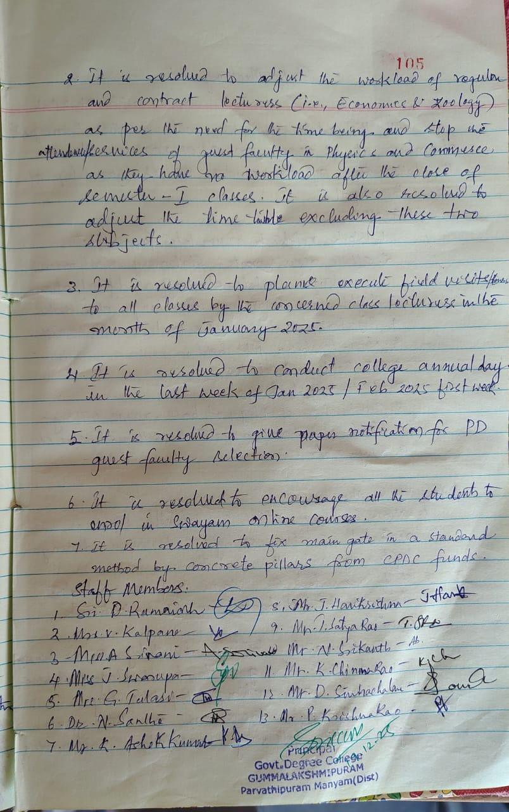

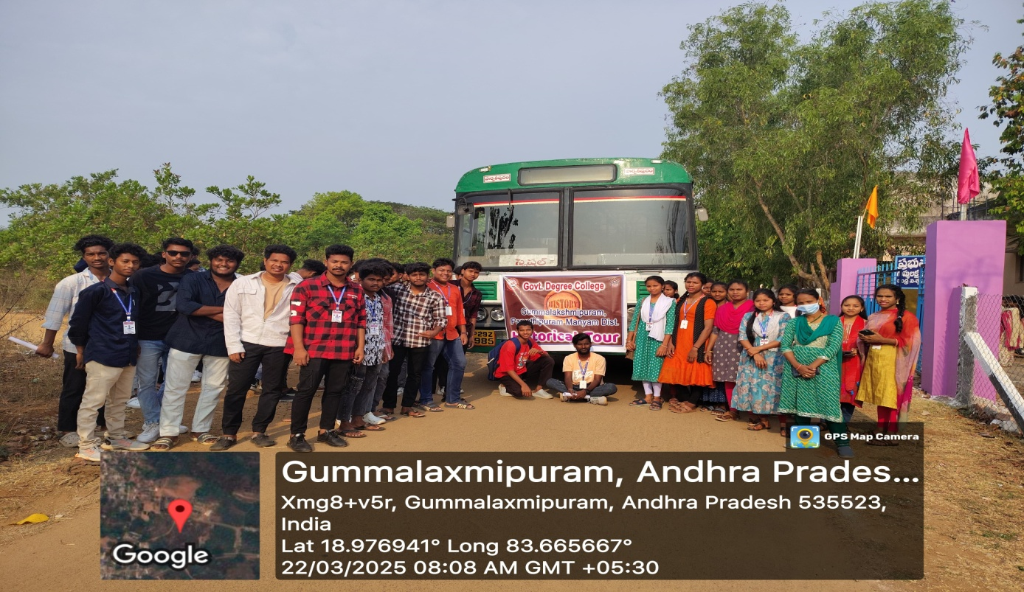

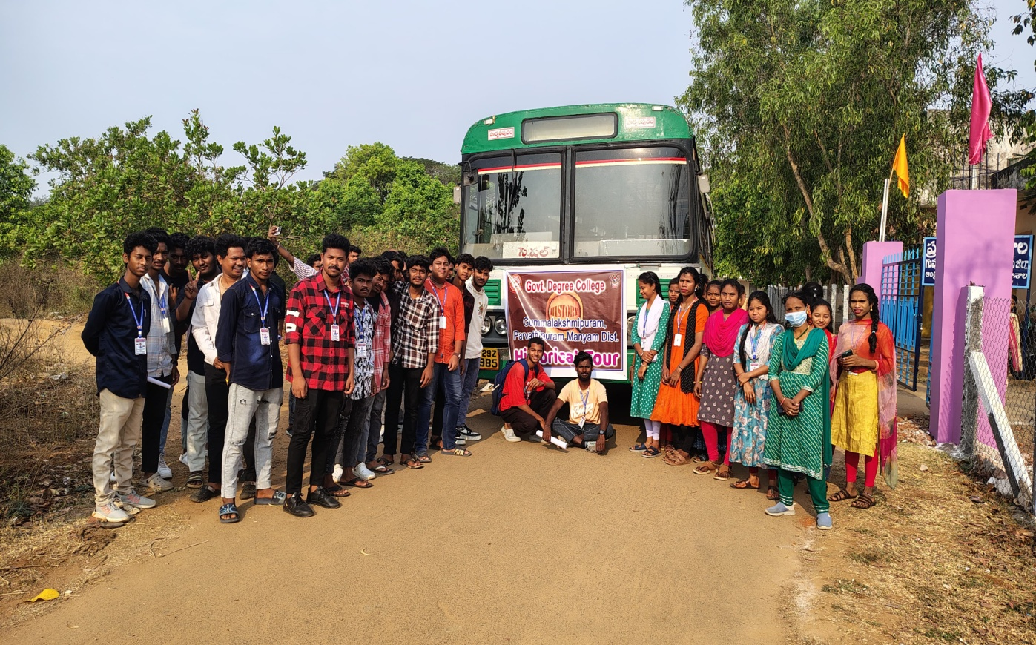

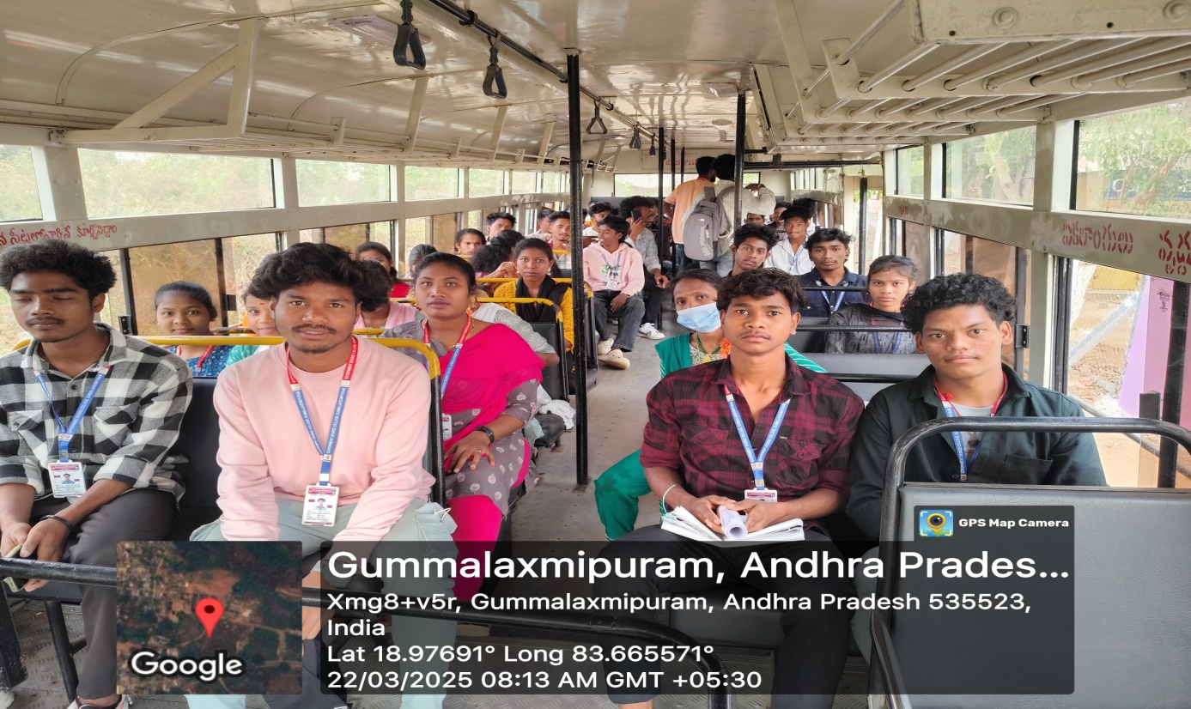

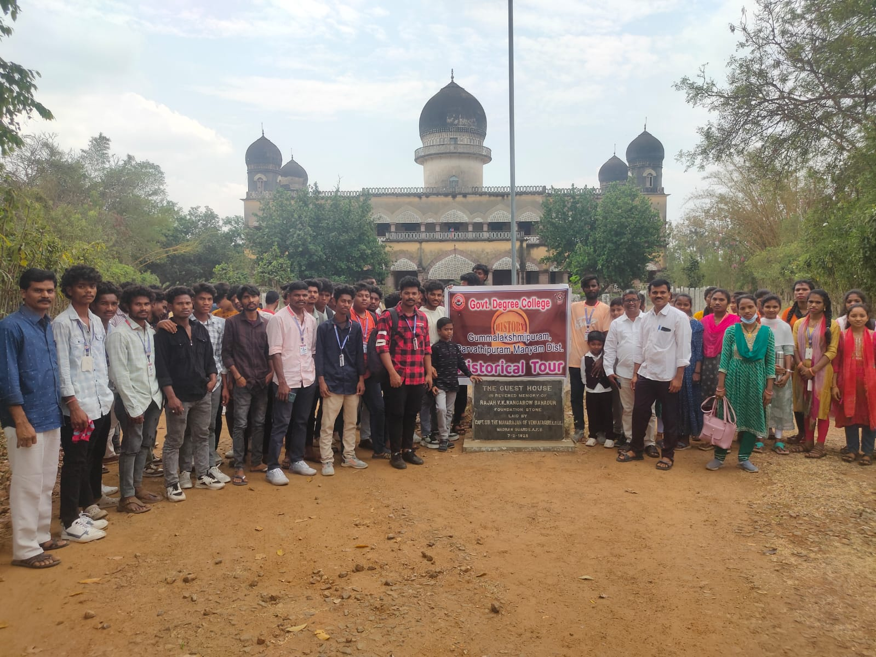

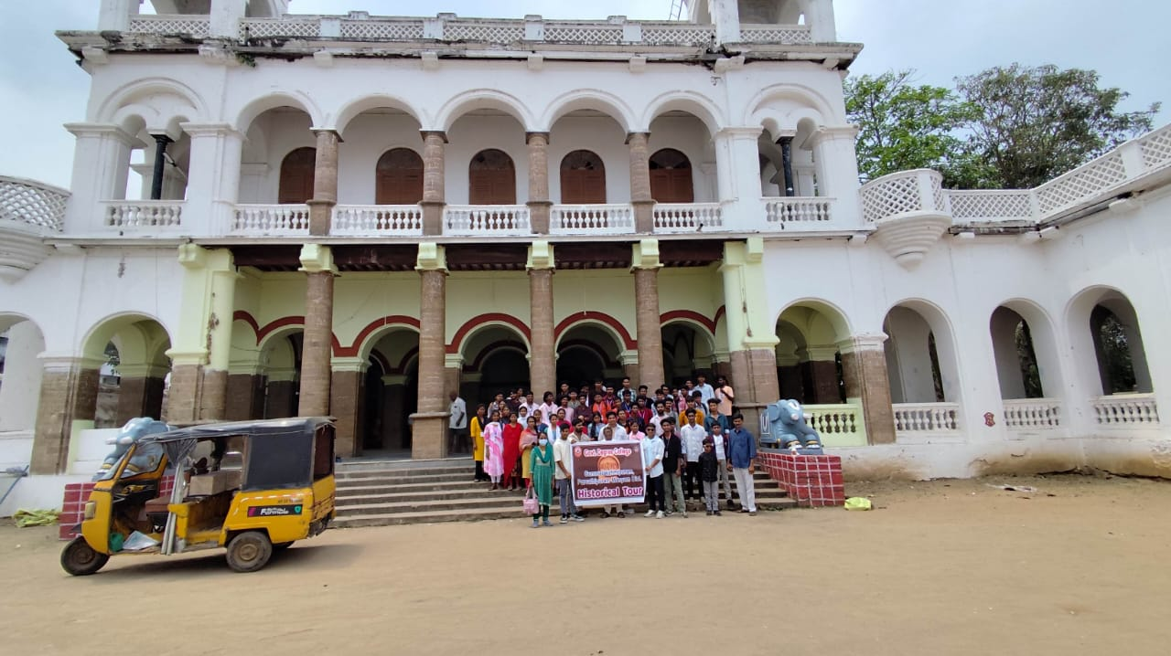

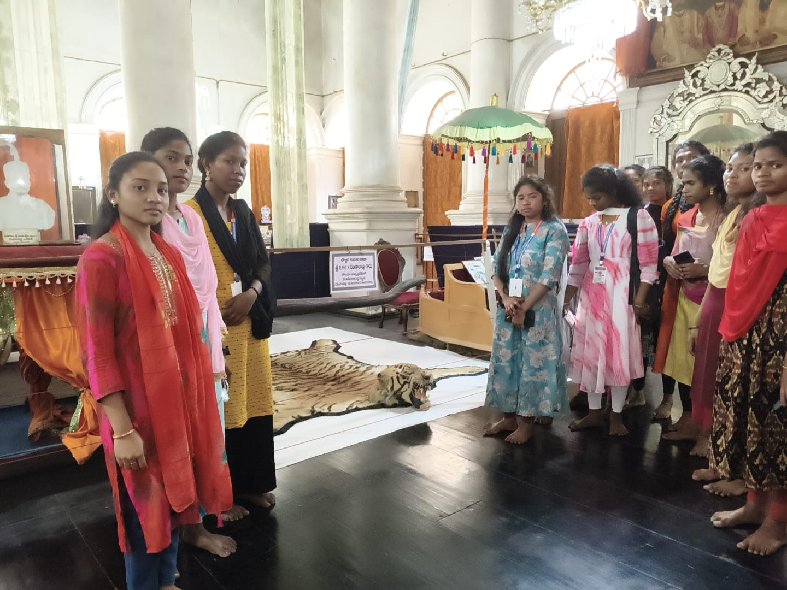

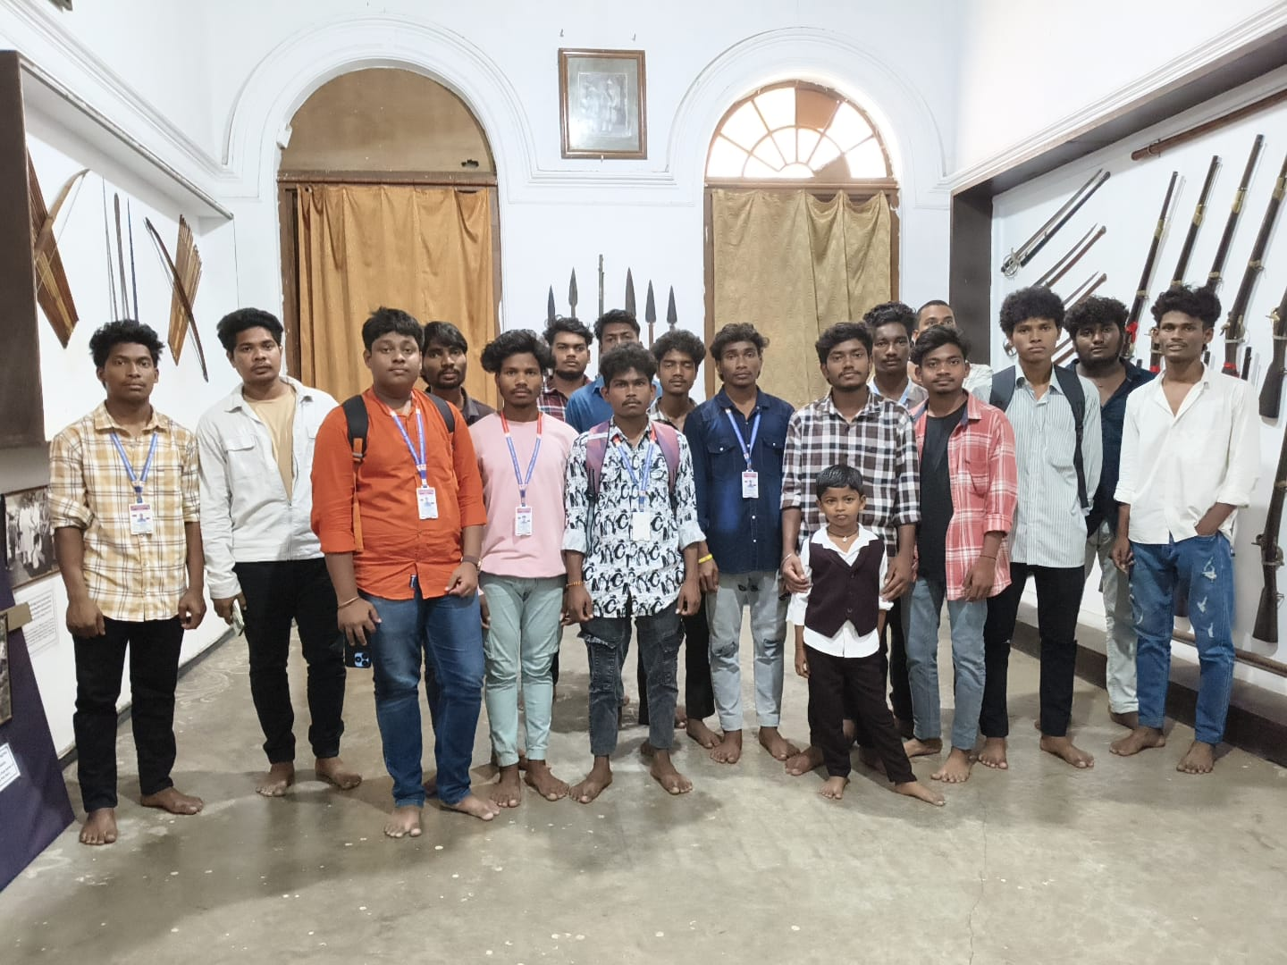

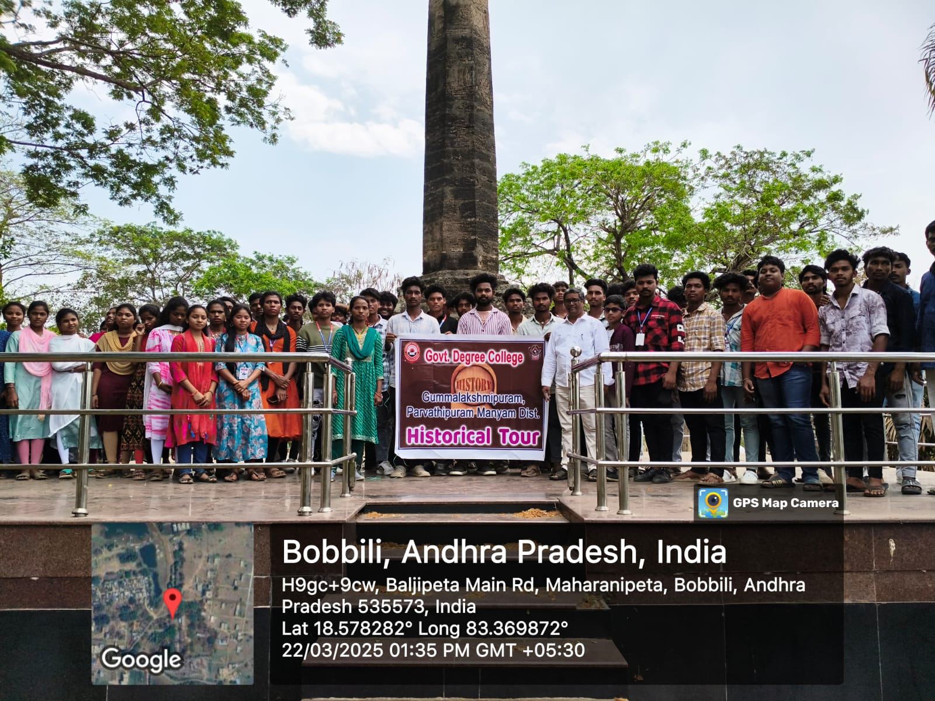

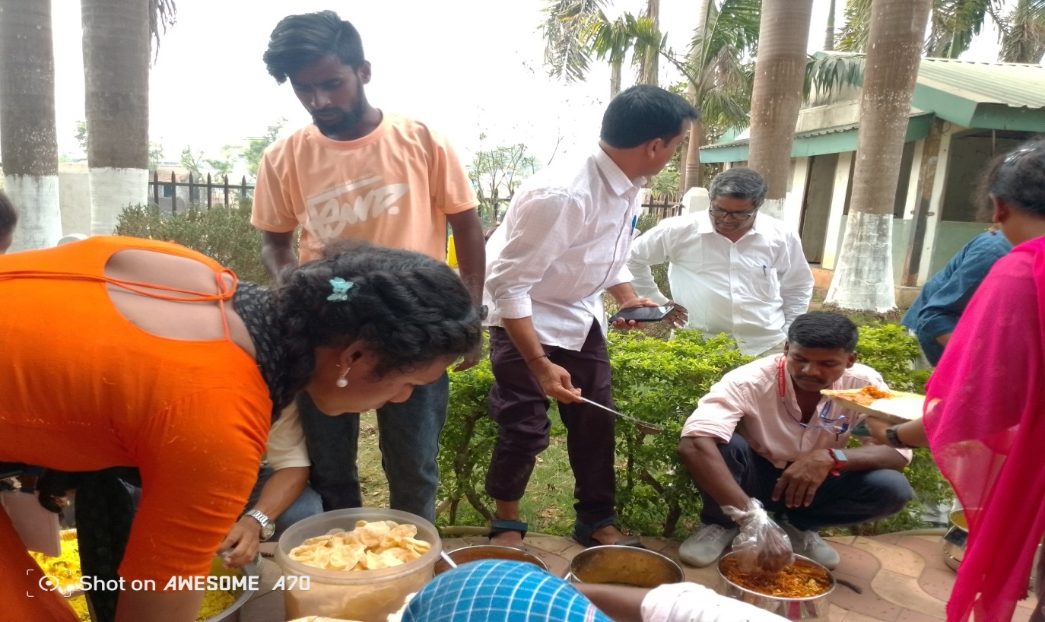

**Lunch Break**

